Line Containment in a Plane

Definition
# Source: AI Source: Provided by: [Data Path: Persons Table -> ID Column: 1, Name_En Column: Motasem Essam] -> From: [ChatGPT] on [7/25/2026]
Line Containment in a Plane occurs when an entire line lies within a plane.
If the line $l$is contained in the plane $Π$, every point on the line is also a point of the plane.
$$\boxed{l⊂Π}$$
In other words:
$$\boxed{P∈l⇒P∈Π}$$
for every point $P$on the line.
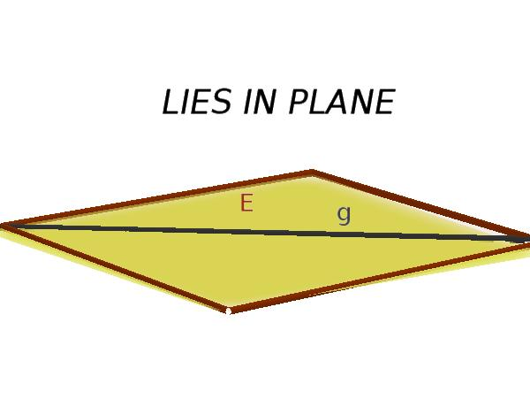
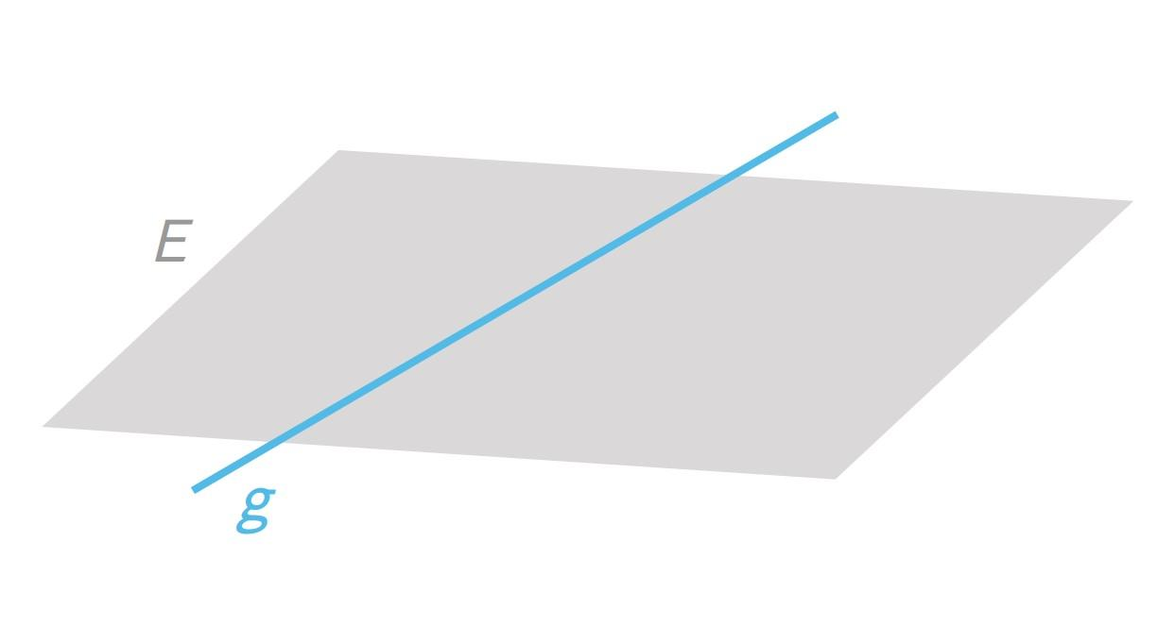
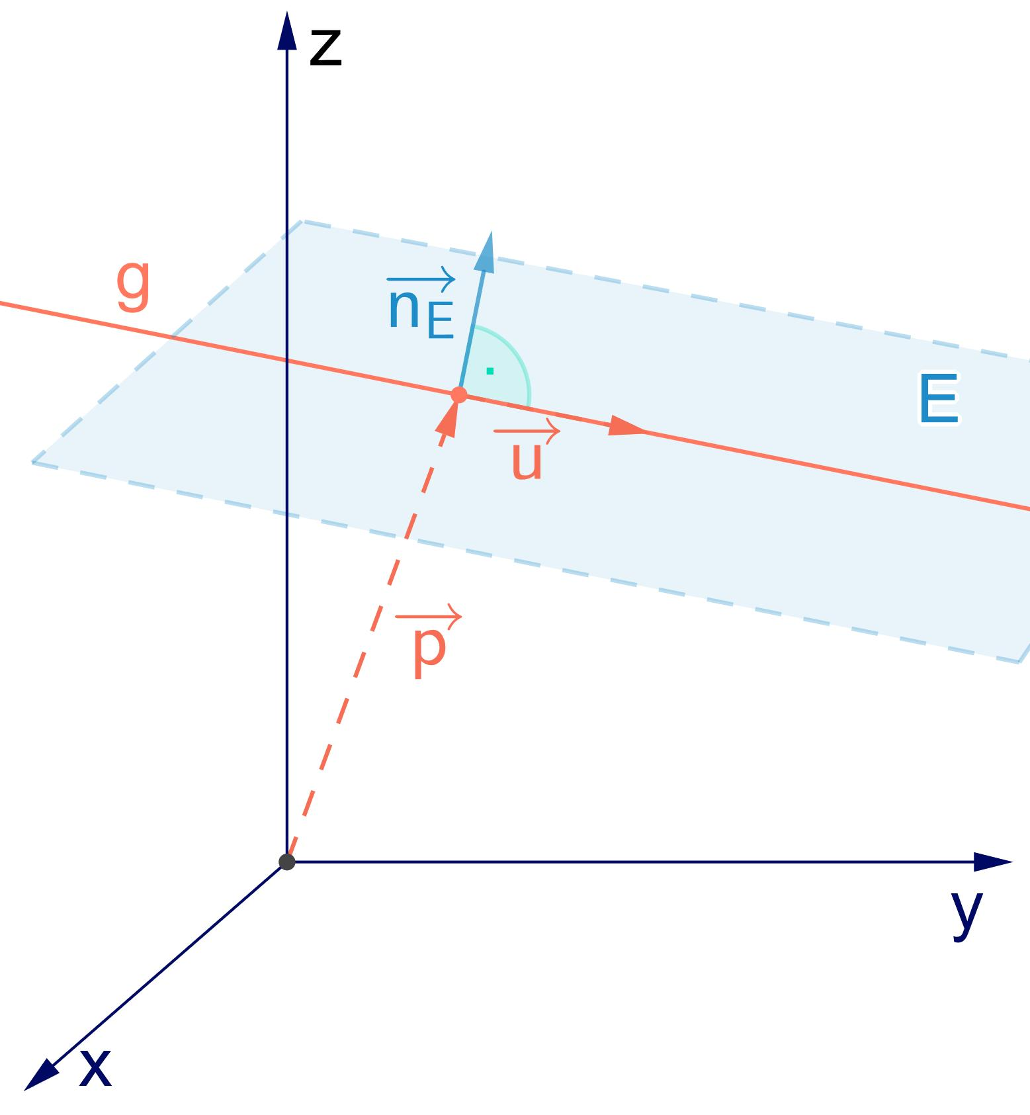
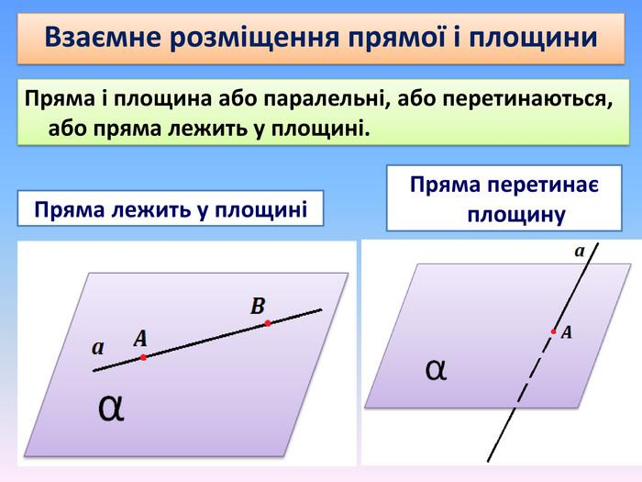

Purpose
# Source: AI Source: Provided by: [Data Path: Persons Table -> ID Column: 1, Name_En Column: Motasem Essam] -> From: [ChatGPT] on [7/25/2026]
Line containment in a plane is used to describe when a complete one-dimensional geometric object—the line—lies inside a two-dimensional geometric object—the plane.
It is important in:
- Euclidean geometry
- Analytic geometry
- 3D coordinate geometry
- Vector geometry
- Engineering
- CAD
- Computer graphics
- Robotics

Fundamental Concept
# Source: AI Source: Provided by: [Data Path: Persons Table -> ID Column: 1, Name_En Column: Motasem Essam] -> From: [ChatGPT] on [7/25/2026]
A plane is an infinite two-dimensional flat surface.
A line is an infinite one-dimensional straight object.
A line can be positioned relative to a plane in several ways:
- The line is contained in the plane.
- The line intersects the plane at one point.
- The line is parallel to the plane and outside it.
The first case is line containment in a plane.
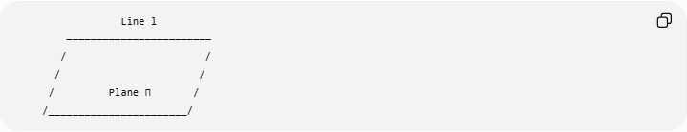
Line l
────────────────────────
/ /
/ /
/ Plane Π /
/_______________________/
The important feature is that the entire line, not merely one point of it, lies in the plane.

Mathematical Representation
# Source: AI Source: Provided by: [Data Path: Persons Table -> ID Column: 1, Name_En Column: Motasem Essam] -> From: [ChatGPT] on [7/25/2026]
If $l$is a line and $Π$is a plane, line containment is written:
$$\boxed{l⊂Π}$$
This means:
$$∀P, P∈l⇒P∈Π$$
It is also possible to write:
$$\boxed{l⊆Π}$$
However, since a line and a plane are different geometric objects and a line cannot equal a plane, the proper-subset notation is often appropriate:
$$\boxed{l⊊Π}$$

Parametric Representation
# Source: AI Source: Provided by: [Data Path: Persons Table -> ID Column: 1, Name_En Column: Motasem Essam] -> From: [ChatGPT] on [7/25/2026]
Suppose a line is given by:
$$r=a+td, t∈R$$
where:
- $a$is a point on the line.
- $d$is the direction vector.
- $t$is a real parameter.
Suppose the plane is:
$$ax+by+cz=d$$
For the entire line to be contained in the plane, every value of $t$must satisfy the plane equation.
Substituting the line into the plane equation gives:
$$a\left(x_{0}+tu_{x}\right)+b\left(y_{0}+tu_{y}\right)+c\left(z_{0}+tu_{z}\right)=d$$
For this to hold for every $t$, two conditions are required.
Condition 1 — A point of the line lies in the plane
$$\boxed{ax_{0}+by_{0}+cz_{0}=d}$$
Condition 2 — The line direction is parallel to the plane
$$\boxed{au_{x}+bu_{y}+cu_{z}=0}$$
Therefore:
$$\boxed{\text{Line }l⊂Π ⟺ \left\{\begin{matrix}\text{a point of }l\text{ lies in }Π, \\ d⋅n=0\end{matrix}\right.}$$
where:
$$n=\left(a , b , c\right)$$
is the normal vector of the plane.

Fundamental Elements
# Source: AI Source: Provided by: [Data Path: Persons Table -> ID Column: 1, Name_En Column: Motasem Essam] -> From: [ChatGPT] on [7/25/2026]
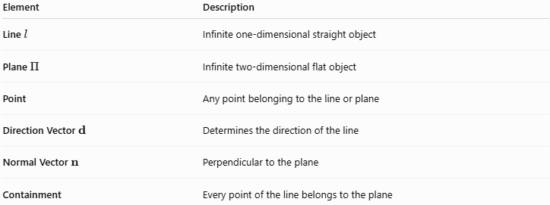
Element | Description
Line $l$ | Infinite one-dimensional straight object
Plane $Π$ | Infinite two-dimensional flat object
Point | Any point belonging to the line or plane
Direction Vector $d$ | Determines the direction of the line
Normal Vector $n$ | Perpendicular to the plane
Containment | Every point of the line belongs to the plane

Example
# Source: AI Source: Provided by: [Data Path: Persons Table -> ID Column: 1, Name_En Column: Motasem Essam] -> From: [ChatGPT] on [7/25/2026]
Consider the plane:
$$Π: x+y+z=6$$
and the line:
$$l:\left(x , y , z\right)=\left(1 , 2 , 3\right)+t\left(1 , - , 10\right)$$
We need to determine whether the line is contained in the plane.

Step 1 — Check a point on the line
# Source: AI Source: Provided by: [Data Path: Persons Table -> ID Column: 1, Name_En Column: Motasem Essam] -> From: [ChatGPT] on [7/25/2026]
The point corresponding to $t=0$is:
$$P=\left(1 , 2 , 3\right)$$
Substitute into the plane:
$$1+2+3=6$$
Therefore:
$$P∈Π$$

Step 2 — Check the direction vector
# Source: AI Source: Provided by: [Data Path: Persons Table -> ID Column: 1, Name_En Column: Motasem Essam] -> From: [ChatGPT] on [7/25/2026]
The line direction vector is:
$$d=\left(1 , - , 10\right)$$
The plane normal vector is:
$$n=\left(1 , 1 , 1\right)$$
Calculate the dot product:
$$d⋅n=\left(1\right)\left(1\right)+\left(-1\right)\left(1\right)+\left(0\right)\left(1\right) \\ =1-1+0 \\ =0$$
Therefore:
$$d⊥n$$
so the line direction is parallel to the plane.
Since the line has a point in the plane and its direction is parallel to the plane:
$$\boxed{l⊂Π}$$
Thus the entire line is contained in the plane.

Geometric Interpretation
# Source: AI Source: Provided by: [Data Path: Persons Table -> ID Column: 1, Name_En Column: Motasem Essam] -> From: [ChatGPT] on [7/25/2026]
A line contained in a plane does not merely touch the plane.
Instead:
$$\boxed{\text{Every point of the line belongs to the plane}}$$
For example:
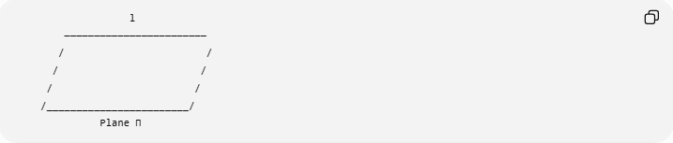
l
────────────────────────
/ /
/ /
/ /
/________________________/
Plane Π
The line can move in any direction within the plane, but it never leaves the plane.

Two Distinct Points Determine the Contained Line
# Source: AI Source: Provided by: [Data Path: Persons Table -> ID Column: 1, Name_En Column: Motasem Essam] -> From: [ChatGPT] on [7/25/2026]
If two distinct points $A$and $B$both lie in a plane:
$$A∈Π$$
and:
$$B∈Π$$
then the entire line determined by those two points lies in the plane:
$$\boxed{A,B∈Π ⇒ \overset{↔}{AB}⊂Π}$$
This is one of the fundamental principles behind line-plane geometry.
Why?
The line through two distinct points is unique, and a plane containing both points contains the entire line determined by them.

Important Theorem
# Source: AI Source: Provided by: [Data Path: Persons Table -> ID Column: 1, Name_En Column: Motasem Essam] -> From: [ChatGPT] on [7/25/2026]
Two-Point Line Containment Theorem
If two distinct points of a line lie in a plane, then the entire line lies in that plane.
Given:
$$A,B∈Π$$
with:
$$A≠B$$
then:
$$\boxed{\overset{↔}{AB}⊂Π}$$
This provides a simple geometric test for line containment.

Line–Plane Positional Relationships
# Source: AI Source: Provided by: [Data Path: Persons Table -> ID Column: 1, Name_En Column: Motasem Essam] -> From: [ChatGPT] on [7/25/2026]
A line and plane in three-dimensional Euclidean geometry can have three fundamental positional relationships.
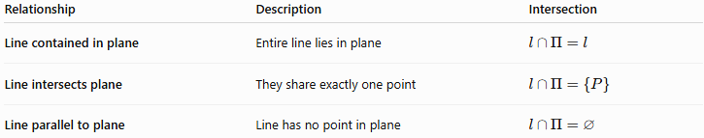
Relationship | Description | Intersection
Line contained in plane | Entire line lies in plane | $$l∩Π=l$$
Line intersects plane | They share exactly one point | $$l∩Π=\left\{P\right\}$$
Line parallel to plane | Line has no point in plane | $$l∩Π=∅$$
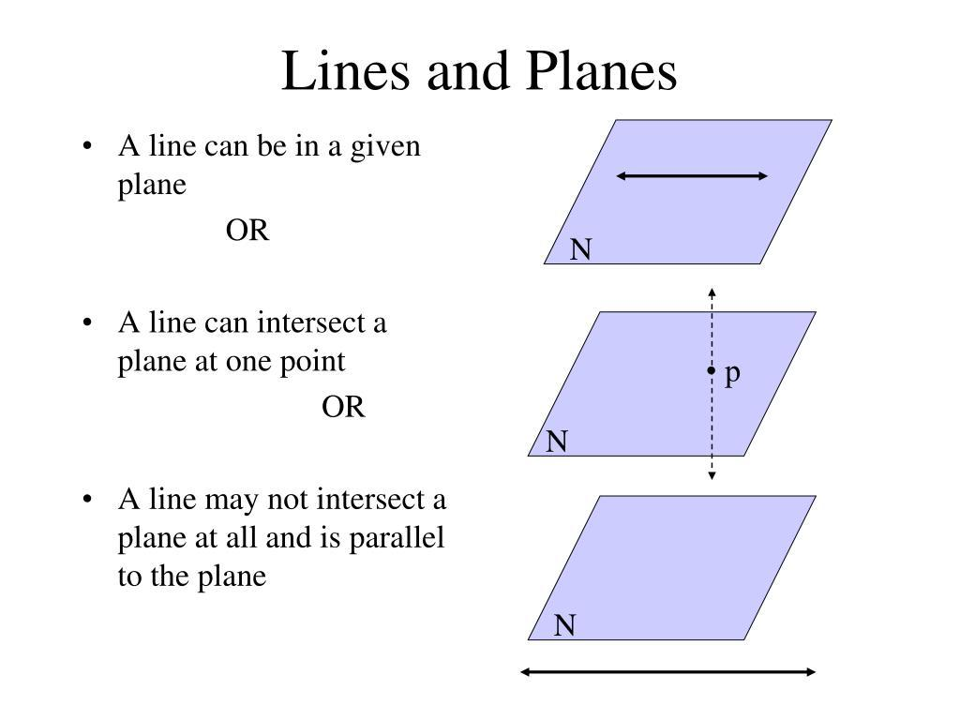
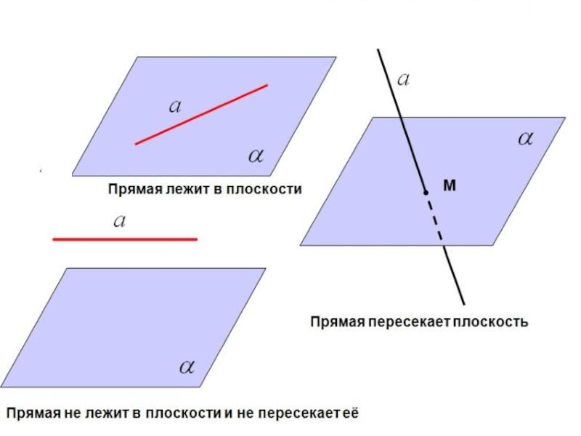
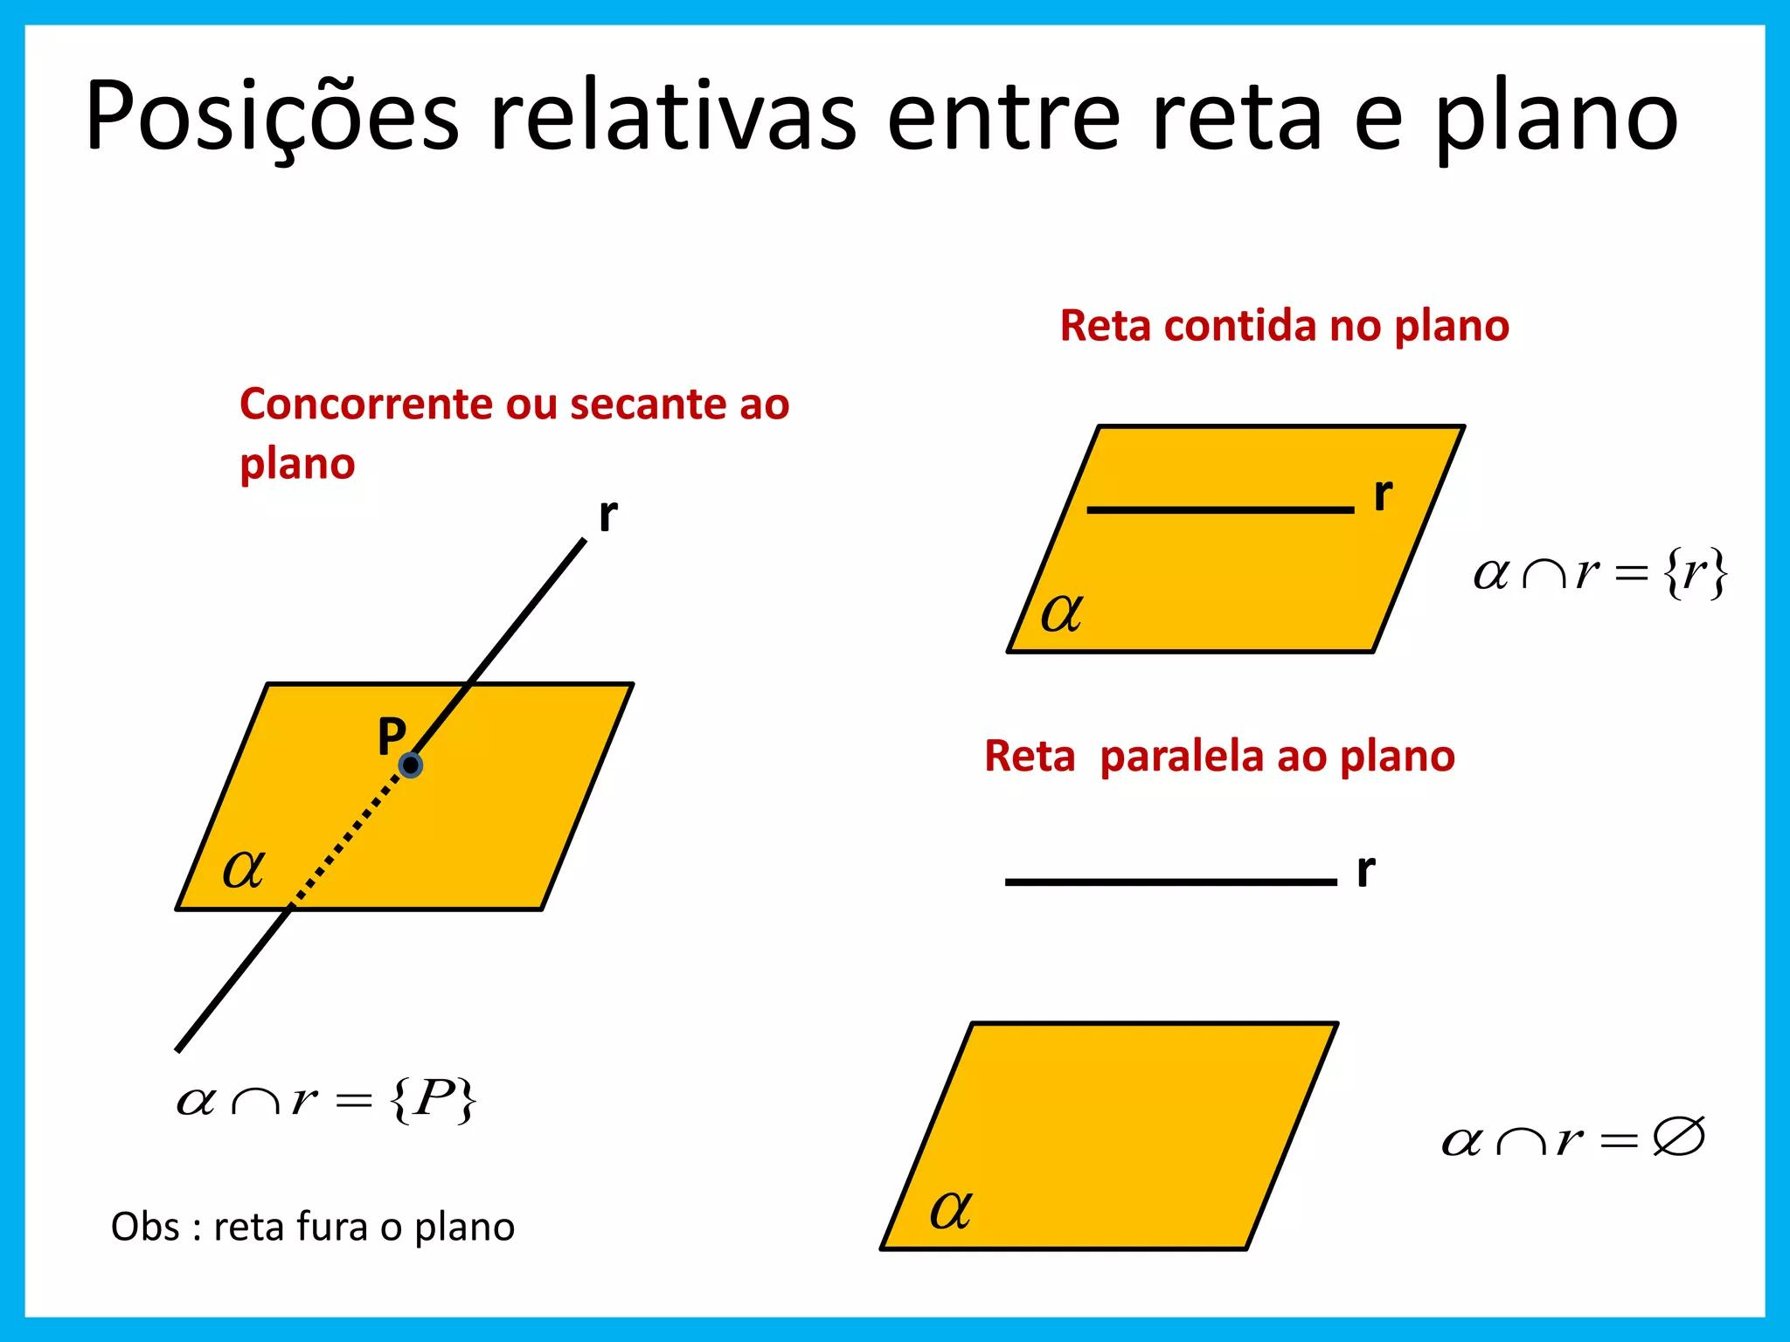

Line Contained in Plane vs. Line Intersecting Plane
# Source: AI Source: Provided by: [Data Path: Persons Table -> ID Column: 1, Name_En Column: Motasem Essam] -> From: [ChatGPT] on [7/25/2026]
These relationships are different.
Containment
$$\boxed{l⊂Π}$$
Every point of $l$belongs to $Π$.
Therefore:
$$l∩Π=l$$
Single-Point Intersection
$$\boxed{l∩Π=\left\{P\right\}}$$
Only one point is shared.
The line passes through the plane but does not lie completely within it.

Line Contained in Plane vs. Line Parallel to Plane
# Source: AI Source: Provided by: [Data Path: Persons Table -> ID Column: 1, Name_En Column: Motasem Essam] -> From: [ChatGPT] on [7/25/2026]
A line parallel to a plane and outside it satisfies:
$$l∩Π=∅$$
while a contained line satisfies:
$$l∩Π=l$$
Therefore:
$$\boxed{l⊂Π ≠ l∥Π}$$
A line contained in a plane has a direction parallel to the plane, but it is not usually classified simply as an external parallel line because it actually belongs to the plane.

Line Containment and Intersection
# Source: AI Source: Provided by: [Data Path: Persons Table -> ID Column: 1, Name_En Column: Motasem Essam] -> From: [ChatGPT] on [7/25/2026]
Containment produces a special intersection relationship.
If:
$$l⊂Π$$
then:
$$\boxed{l∩Π=l}$$
This is different from the usual line-plane intersection:
$$l∩Π=\left\{P\right\}$$
where only one point is shared.
Thus, intersection describes the common part, while containment describes the complete inclusion of one object within another.

Line Containment and Coincidence
# Source: AI Source: Provided by: [Data Path: Persons Table -> ID Column: 1, Name_En Column: Motasem Essam] -> From: [ChatGPT] on [7/25/2026]
A line and a plane cannot be coincident.
Coincidence requires two objects to occupy exactly the same geometric set.
But:
- a line is one-dimensional;
- a plane is two-dimensional.
Therefore:
$$\boxed{l⊊Π}$$
rather than:
$$l=Π$$
So line-plane containment is fundamentally different from coincidence.

Coordinate Geometry Test
# Source: AI Source: Provided by: [Data Path: Persons Table -> ID Column: 1, Name_En Column: Motasem Essam] -> From: [ChatGPT] on [7/25/2026]
For a plane:
$$Π:ax+by+cz=d$$
and line:
$$l:\left(x , y , z\right)=\left(x_{0} , y_{0} , z_{0}\right)+t\left(u_{x} , u_{y} , u_{z}\right)$$
the line is contained in the plane if:
$$\boxed{ax_{0}+by_{0}+cz_{0}=d}$$
and:
$$\boxed{au_{x}+bu_{y}+cu_{z}=0}$$
The first condition verifies that the line starts at a point on the plane.
The second condition verifies that the line's direction remains within the plane.

Special Case: Coordinate Planes
# Source: AI Source: Provided by: [Data Path: Persons Table -> ID Column: 1, Name_En Column: Motasem Essam] -> From: [ChatGPT] on [7/25/2026]
Consider the $xy$-plane:
$$z=0$$
A line:
$$\left(x , y , z\right)=\left(1 , 2 , 0\right)+t\left(3 , 4 , 0\right)$$
has:
$$z=0$$
for every value of $t$.
Therefore:
$$\boxed{l⊂xy\text{-plane}}$$
Similarly, a line can be contained in:
$$xz\text{-plane}:y=0$$
or:
$$yz\text{-plane}:x=0$$

Examples of Lines Contained in Coordinate Planes

Line in the $xy$-Plane
# Source: AI Source: Provided by: [Data Path: Persons Table -> ID Column: 1, Name_En Column: Motasem Essam] -> From: [ChatGPT] on [7/25/2026]
$$z=0$$
Example:
$$\left(x , y , z\right)=\left(2 , 3 , 0\right)+t\left(1 , 2 , 0\right)$$
Therefore:
$$l⊂xy\text{-plane}$$

Line in the $xz$-Plane
# Source: AI Source: Provided by: [Data Path: Persons Table -> ID Column: 1, Name_En Column: Motasem Essam] -> From: [ChatGPT] on [7/25/2026]
$$y=0$$
Example:
$$\left(x , y , z\right)=\left(2 , 0 , 4\right)+t\left(1 , 0 , -2\right)$$
Therefore:
$$l⊂xz\text{-plane}$$

Line in the $yz$-Plane
# Source: AI Source: Provided by: [Data Path: Persons Table -> ID Column: 1, Name_En Column: Motasem Essam] -> From: [ChatGPT] on [7/25/2026]
$$x=0$$
Example:
$$\left(x , y , z\right)=\left(0 , 3 , 2\right)+t\left(0 , 1 , 4\right)$$
Therefore:
$$l⊂yz\text{-plane}$$

Relationship with Other Containment Types
# Source: AI Source: Provided by: [Data Path: Persons Table -> ID Column: 1, Name_En Column: Motasem Essam] -> From: [ChatGPT] on [7/25/2026]
Line containment in a plane extends the containment hierarchy from lower-dimensional objects to higher-dimensional objects.
For example:
$$\boxed{\text{Point}⊂\text{Line}⊂\text{Plane}}$$
A point may be contained in a line, and that line may be contained in a plane.
Thus:
$$P∈l \text{and} l⊂Π$$
implies:
$$\boxed{P∈Π}$$
This demonstrates the transitivity of containment.

Relationship with Segment Containment
# Source: AI Source: Provided by: [Data Path: Persons Table -> ID Column: 1, Name_En Column: Motasem Essam] -> From: [ChatGPT] on [7/25/2026]
If a line is contained in a plane:
$$l⊂Π$$
and a segment lies on that line:
$$\overset{‾}{AB}⊂l$$
then:
$$\boxed{\overset{‾}{AB}⊂Π}$$
Therefore:
$$\boxed{\overset{‾}{AB}⊂l⊂Π}$$
and hence:
$$\boxed{\overset{‾}{AB}⊂Π}$$
The same idea applies to rays:
$$\vec{AB}⊂l$$
and:
$$l⊂Π$$
therefore:
$$\boxed{\vec{AB}⊂Π}$$

Containment Chain
# Source: AI Source: Provided by: [Data Path: Persons Table -> ID Column: 1, Name_En Column: Motasem Essam] -> From: [ChatGPT] on [7/25/2026]
The most important containment chain for these linear objects is:
$$\boxed{\overset{‾}{AB}⊂\vec{AB}⊂\overset{↔}{AB}⊂Π}$$
where:
- $\overset{‾}{AB}$is a line segment;
- $\vec{AB}$is a ray;
- $\overset{↔}{AB}$is a line;
- $Π$is a plane.
This illustrates increasing geometric extent and dimension.

Real-World Applications
# Source: AI Source: Provided by: [Data Path: Persons Table -> ID Column: 1, Name_En Column: Motasem Essam] -> From: [ChatGPT] on [7/25/2026]
Engineering
A straight edge or structural member can be modeled as a line contained in a reference plane.
CAD
A line lying on a planar face is represented by line-plane containment.
Architecture
Walls, floor plans, and construction drawings use lines contained in planes.
Computer Graphics
3D models use planar surfaces and edges, where model edges can be represented by lines or line segments contained in planes.
Robotics
Robot motion constrained to a flat surface can be modeled using lines contained within a plane.
Surveying
Straight survey lines can be modeled as lines lying in a horizontal or vertical reference plane.

Key Properties
# Source: AI Source: Provided by: [Data Path: Persons Table -> ID Column: 1, Name_En Column: Motasem Essam] -> From: [ChatGPT] on [7/25/2026]
- A line contained in a plane has every point in the plane.
- The relationship is written:
$$\boxed{l⊂Π}$$
- Two distinct points of a line lying in a plane imply that the entire line lies in the plane.
- A contained line has a direction parallel to the plane.
- A contained line is not the same as a line outside the plane that is parallel to it.
- If $l⊂Π$, then:
$$l∩Π=l$$
- A line and plane cannot be coincident because they have different dimensions.
- A segment or ray contained in a contained line is also contained in the plane.
- Containment is transitive:
$$A⊂B, B⊂C⇒A⊂C$$
- Line containment in a plane is a fundamental relationship in three-dimensional geometry.

Comparison with Related Concepts
# Source: AI Source: Provided by: [Data Path: Persons Table -> ID Column: 1, Name_En Column: Motasem Essam] -> From: [ChatGPT] on [7/25/2026]
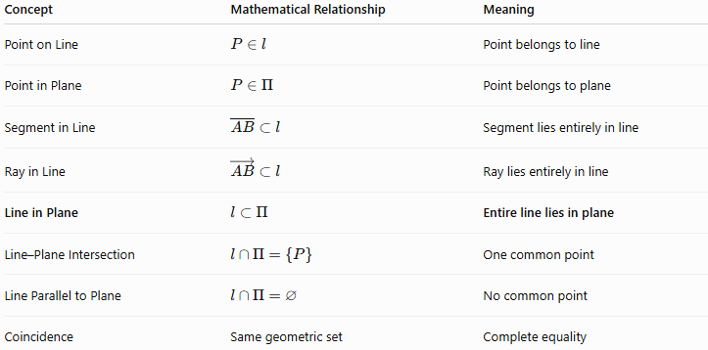
Concept | Mathematical Relationship | Meaning
Point on Line | $$P∈l$$ | Point belongs to line
Point in Plane | $$P∈Π$$ | Point belongs to plane
Segment in Line | $$\overset{‾}{AB}⊂l$$ | Segment lies entirely in line
Ray in Line | $$\vec{AB}⊂l$$ | Ray lies entirely in line
Line in Plane | $$l⊂Π$$ | Entire line lies in plane
Line–Plane Intersection | $$l∩Π=\left\{P\right\}$$ | One common point
Line Parallel to Plane | $$l∩Π=∅$$ | No common point
Coincidence | Same geometric set | Complete equality

Conclusion
# Source: AI Source: Provided by: [Data Path: Persons Table -> ID Column: 1, Name_En Column: Motasem Essam] -> From: [ChatGPT] on [7/25/2026]
Line Containment in a Plane means that an entire infinite line lies within an infinite plane:
$$\boxed{l⊂Π}$$
Every point of the line belongs to the plane. A particularly important test is that two distinct points of a line lying in a plane guarantee that the entire line lies in that plane:
$$\boxed{A,B∈Π, A≠B⇒\overset{↔}{AB}⊂Π}$$
This relationship is fundamental for understanding line-plane relationships, 3D coordinate geometry, vectors, intersections, and higher-dimensional containment.

